ARTS IMPACT LESSON PLAN
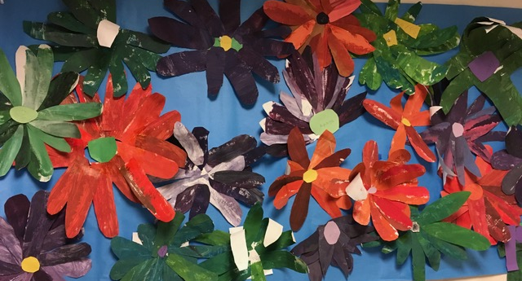
Visual Arts and Science Infused Lesson

Flower Garden Mural
Authors: Nicole Radosevich with Carol Gould Grade Level: 1

Enduring Understanding
Color values and overlapping shapes can show plant structures.

Lesson Description (Use for family communication and displaying student art)
Students mix paint and create process paper using tints and shades to show value. Process paper is then cut into flower petal shapes and layered to create individual flowers that will become part of a group collage. Next, students collaboratively work to combine their flowers in a garden collage mural.

Learning Targets and Assessment Criteria
Target: Mix secondary colors and color values.
Criteria: Combines primary colors to make secondary colors. Uses white and black to create tints and shades.

Target: Recognizes overlapping in nature and creates in work of art.
Criteria: Observes real flowers and layers paper flower petals partially over other petals to create an overlapping collage.

Target: Uses craftsmanship.
Criteria: Folds, draws, and cuts carefully and glues intentionally.

Target: Works collaboratively.
Criteria: Shares, discusses, listens to each other’s ideas and makes decisions to collectively
create a flower garden mural.
Vocabulary
Arts Infused:
Color
Observation
Shape

Science:
Flower
Leaves
Petal
Roots
Seed
Stem

Arts:
Collage
Craftsmanship
Layer
Monochromatic
Mural
Overlapping
Primary
Secondary
Shade
Tint
Value

Materials
Museum Artworks or Performance
SAM: John La Farge, Peonies in the Wind, 87.143
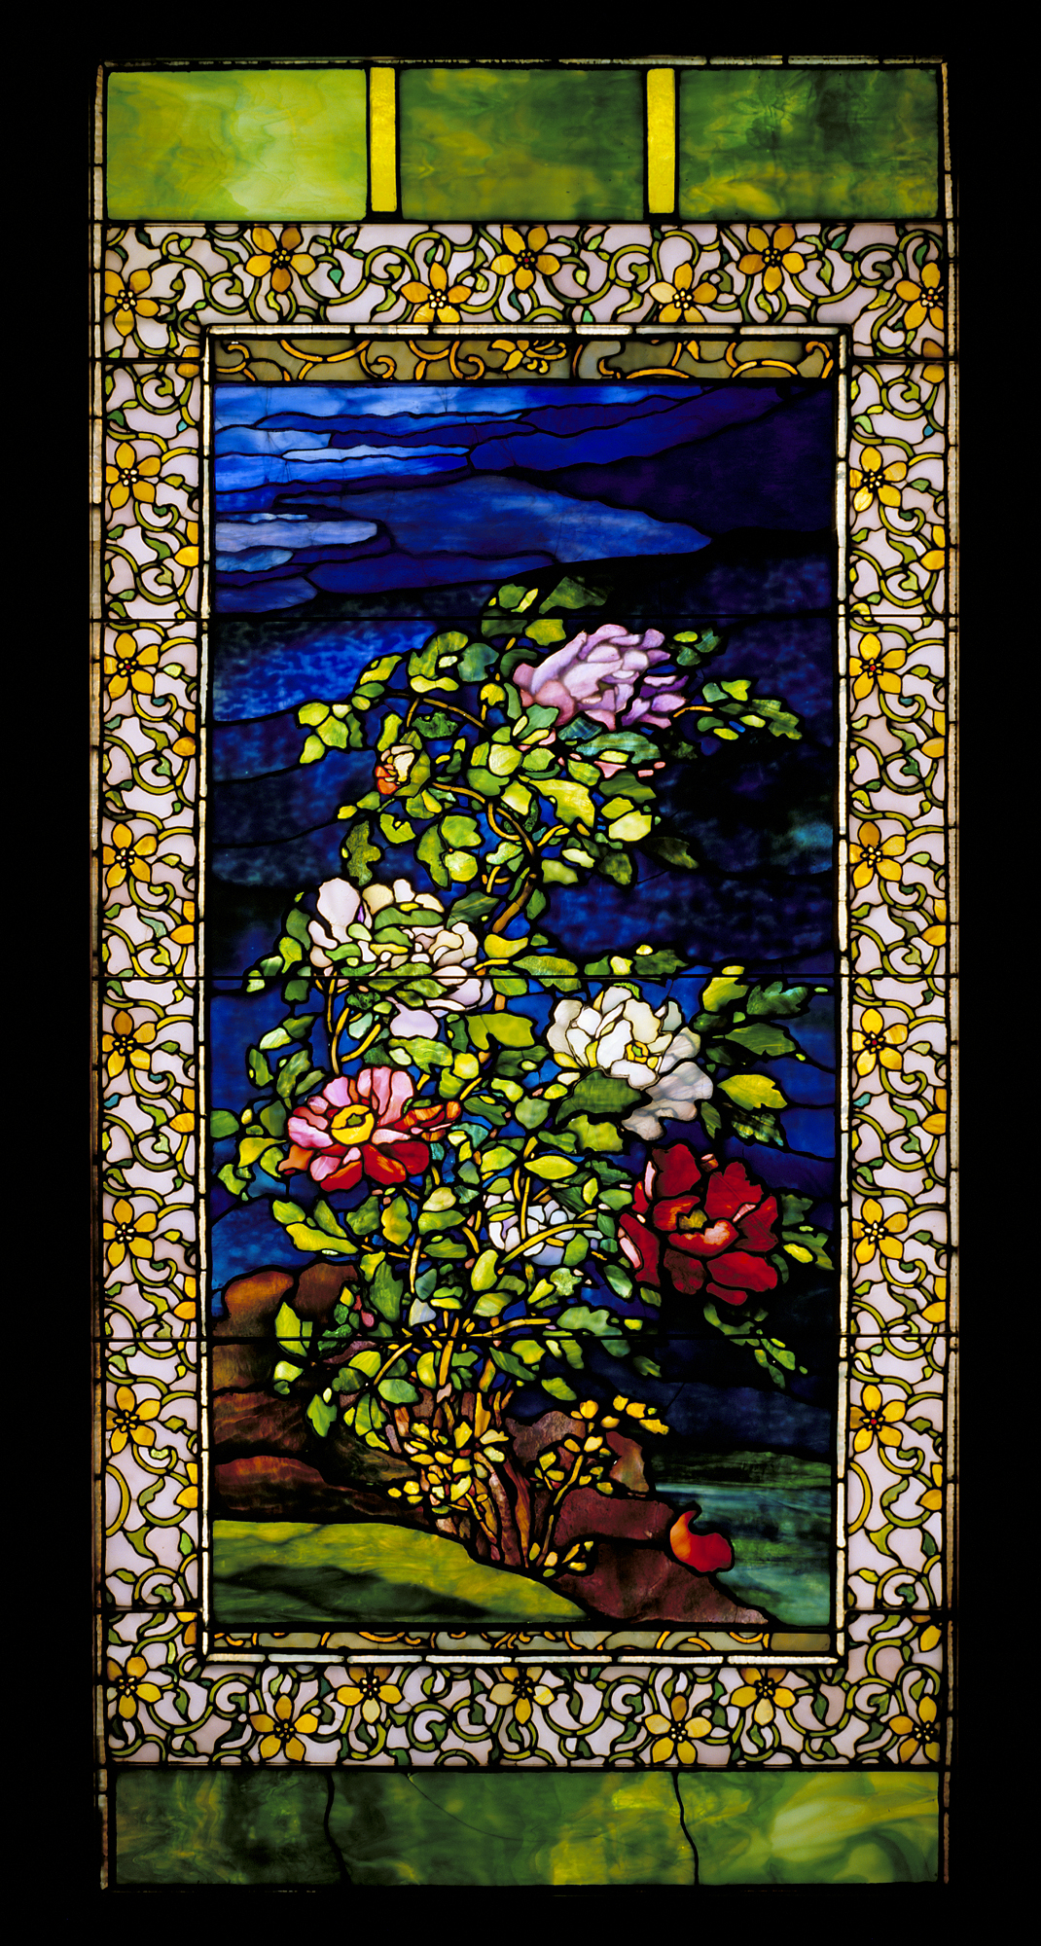
Georgia O’Keeffe, Red Poppies
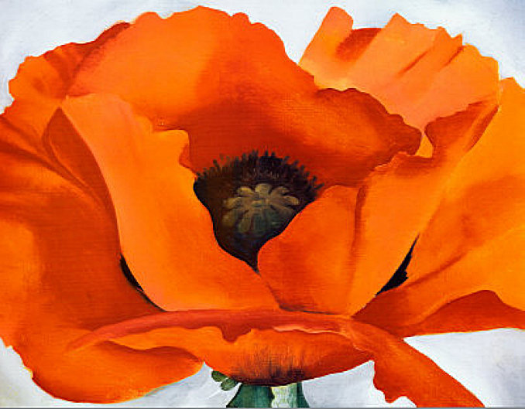

Materials
Sketchbooks, Color pencils, Color wheel, Drawing paper 18x24”, Tempera Paint: Primary colors and white and black, Paint trays, Paint brushes, Mod Podge and/or acrylic paint, Fresh Flowers, Pencils, scissors, glue, Mural surface? (butcher paper?)
Learning Standards
WA Arts State Grade Level Expectations
For the full description of each WA State Arts Grade Level Expectation, see: http://www.k12.wa.us/Arts/Standards
http://www.k12.wa.us/Arts/Standards
1.1.1 Elements: Line
1.1.2 Elements: Shape
1.1.6 Elements: Color
1.1.2 Skills and Techniques: Drawing, Collage
2.1.1 Creative Process
2.2.1 Presenting Process
2.3.1 Responding Process

continued
Early Learning Guidelines, if applicable
For a full description of Washington State Early Learning and Child Development Guidelines see: http://www.k12.wa.us/EarlyLearning/guidelines.asp
(Grade 1) 6. Learning about my world: Arts: Create and respond to arts.

Next Generation Science Standards
Most closely connected to lesson:
http://www.nextgenscience.org/next-generation-science-standards

Performance Expectations
1-LS1-1. Use materials to design a solution to a human problem by mimicking how plants and /or animals use their external parts to help them survive, grow and meet their needs.

Science and Engineering Practices
2. Developing and Using Models

Disciplinary Core Ideas
LS1.A: Structure and Function

Crosscutting Concepts
Structure and Function

Pre-Teach
ICON KEY:

= Indicates note or reminder for teacher

= Embedded assessment points in the lesson

Review parts of plant: roots, stem, leaves, flower, seeds, or color.
Lesson Steps Outline
Day One
1. Introduce flower mural project. Demonstrate and guide color mixing to create secondary colors, tints and shades.

Criteria-based teacher checklist: Combines primary colors to make secondary colors. Uses white and black to create tints and shades.

Day Two
2. Introduce and guide discussion about work of art, Red Poppies by Georgia O’Keeffe. Connect learning with plant structure/parts science concepts. Guide practice finding and making color values in petal shapes.

Criteria-based process assessment: Participates in discussion of value and tints and shades.

Day Three
3. Guide students to look at real flowers and Peonies in the Wind by
John La Farge from SAM with an eye for overlapping. Demonstrate process
of paper folding, cutting and arranging petals to make flower with emphasis
on craftsmanship.

Criteria-based teacher checklist: Observes real flowers, folds, draws, cuts carefully and glues securely. Layers paper flower petals partially over other petals to create an overlapping collage.

Day Four
4. Guide group collaboration as students collectively decide how to combine flower collages into one mural. Encourage reflection as artistic decisions are made and in response to final mural.

Criteria-based teacher checklist: Layers paper flower petals partially over other petals to create an overlapping collage. Shares, discusses, listens to each other’s ideas and makes decisions to collectively make a flower garden mural. Glues intentionally.
LESSON STEPS____________________________________________
Day One
1. Introduce flower mural project. Demonstrate and guide color mixing to create secondary colors, tints and shades.

- We are going to be looking at art, discussing art and making art. You will be mixing colors, painting, cutting and overlapping paper to make flowers.

- Secondary colors are those that are made from mixing two primary colors. Let’s look at the color wheel: Turn to your partner and tell them the 3 primary colors.

Students share with partner and to whole group.

- The primary colors are red yellow and blue. These can be combined to create secondary colors. Let’s look on the color wheel and see which colors we need to make orange… violet (purple)… and green. These are called secondary colors. One primary color + One primary color = a secondary color.
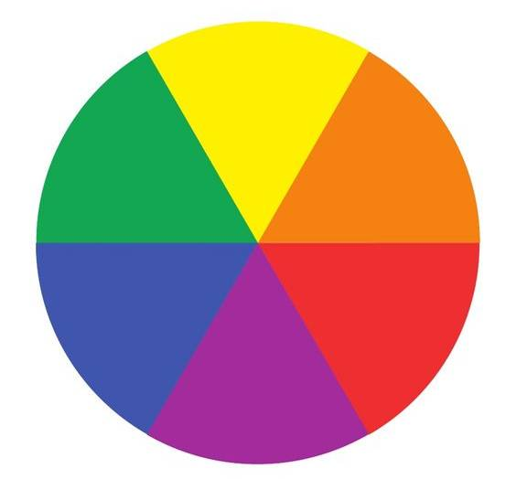

- When you add white to a color it is called a tint. When you add black to a color it is called a tone/shade. Where do you see tints and tones/shades of the main color in each composition?

- When an artist uses mostly tints and tones/shades of one color in a composition, we describe the work as having a monochromatic color scheme. Monochromatic means “one color.”

- Now it’s time to create our process paper, this paper will become the petals of our flowers. Watch me mix primary color red and the primary color blue to make the secondary color violet (purple).

- Now I’m using a spoon add in white to make a tint. I want to have a variety of values, I will cover my sheet of paper with different values of violet (purple) paint making sure I have some dark, medium values of violet (purple).

Students will choose 2 primary colors to combine to make a secondary color and make process paper that will dry for Day 2 of lesson.

Teacher should make extra process paper.

Criteria-based teacher checklist: Combines primary colors to make secondary colors. Uses white and black to create tints and shades.
_______________________________________________________________________

Day Two
2. Introduce and guide discussion about work of art, Red Poppies by Georgia O’Keeffe.
Connect learning with plant structure/parts science concepts. Guide practice finding and making color values in petal shapes.

- Let’s look at the work of artist Georgia O’Keeffe. Tell me what you see. What are some of the words from science we can use to describe what we see?

- What color is this flower? Is it all the same color, why or why not? Value means darker and lighter, point to where you see darker or lighter color in this flower.

- Touch the darkest and lightest petal parts.

- Artists create tints by using white paint to lighten the color and black to make the color darker.

- Lets create a tint and a shade in our sketch books, choose one colored pencil and draw a petal shape and fill it with color. Now use the white colored pencil over the top this makes a tint.

Teacher demonstrates using black to show shade.

Criteria-based process assessment: Participates in discussion of value and tints and shades.
_______________________________________________________________________

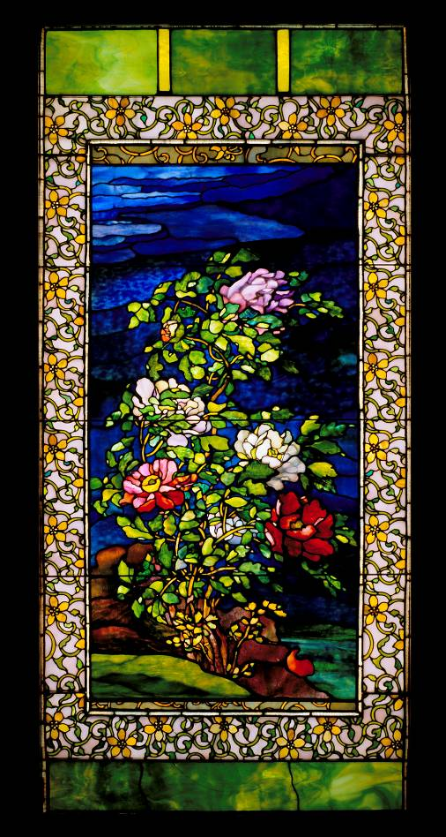
Day Three
3. Guide students to look at real flowers and Peonies in the Wind by John La Farge from SAM with an eye for overlapping.

- What does overlapping mean? What parts of plants are overlapping in this picture and in this real flower?

Demonstrate process of paper folding, cutting and arranging petals to make flower with emphasis on craftsmanship.

- Fold your paper in half the long way (9x24) unfold and cut down the line.

- Start with one half, fold it in half (9x12), and in half again and in half again. Unfold it (9x6 with a crease in the middle)

- Carefully draw 2 large petal shapes on each side of the crease.

- Carefully cut out the petals, each cutting section should yield 4 petals. Repeat with other half of paper (total of16 petals).

Criteria-based teacher checklist: Observes real flowers, folds, draws, cuts carefully, and glues securely. Layers paper flower petals partially over other petals to create an overlapping collage.
_______________________________________________________________________

Day Four
4. Guide group collaboration as students collectively decide how to combine flower collages into one mural. Encourage reflection as artistic decisions are made and in response to final mural.

- We are making a mural: a big work of art that combines all of our flowers. We are designing our mural collaboratively.

- What can we each do to help us all work well together? (Share ideas, discuss, listen, make decisions as a group).

- Stop, look and think as you decide where to place and attach each flower. You will be overlapping parts. Use craftsmanship as you glue. When done, stand back and admire.

Criteria-based teacher checklist: Layers paper flower petals partially over other petals to create an overlapping collage. Shares, discusses, listens to each other’s ideas and makes decisions to collectively make a flower garden mural. Glues intentionally.
___________________________________________________________________

ARTS IMPACT LESSON PLAN Visual Arts and Science Infused Lesson
1st Grade: Flower Garden Mural

CLASS ASSESSMENT WORKSHEET

Disciplines | VISUAL ARTS |  | VISUAL ARTS/SCIENCE | VISUAL ARTS | Total  4
Concept | Color | Collage | Structure | Collaboration
Criteria  Student Name | Combines primary colors to make secondary colors. Uses white and black to create tints and shades. | Folds, draws, and cuts carefully and glues intentionally. | Observes real flowers and layers paper flower petals partially over other petals to create an overlapping collage. | Shares, discusses, listens to each other’s ideas and makes decisions to collectively create a flower garden mural.
1.
2.
3.
4.
5.
6.
7.
8.
9.
10.
11.
12.
13.
14.
15.
16.
17.
18.
19.
20.
21.
22.
23.
24.
25.
26.
27.
28.
29.
30.
Total
Percentage
What was effective in the lesson? Why?

What do I want to consider for the next time I teach this lesson?

What were the strongest connections between arts discipline and subject area?

Teacher: Date:
ARTS IMPACT FAMILY LETTER

ARTS AND SCIENCE INFUSED LESSON: Flower Garden Mural

Dear Family:

Today your child participated in a Visual arts and Science Infused lesson. We looked at flowers in art and nature and noticed their color and overlapping shapes.

- We discovered we could mix paint to create process paper (to use in a collage later) using tints and shades to show value: lights and darks of the same color.
.
- We created flower petal shapes out of our process paper and made them into flowers.

- We worked collaboratively to combine our flowers in a garden collage mural.

At home, you could study other plants and create collages made of colorful scrap papers that show their overlapping shapes.

Enduring Understanding

Color values and overlapping shapes can show plant structures.

